OTC Campus Map
Entrance from parking lot into the west end of the building to the culinary department.

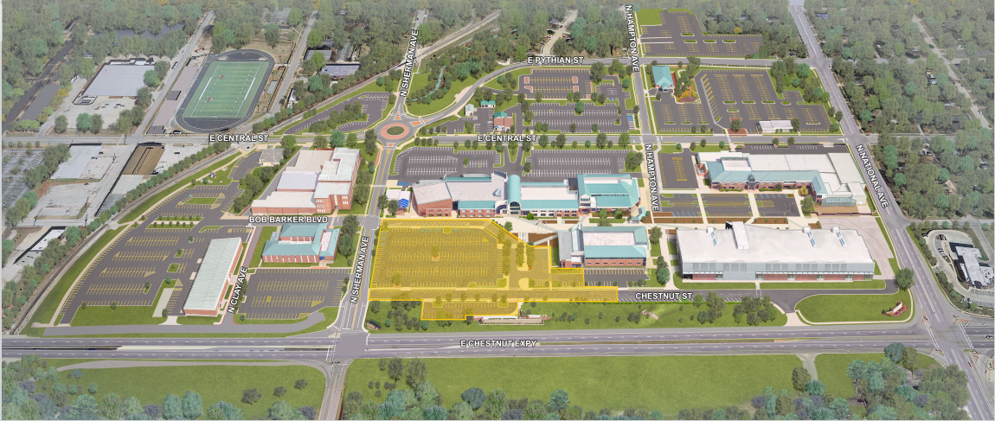
New Construction zone.
Parking

